**BISSIT 2022**

**HANDWRITTEN CHARACTER RECOGNITION PROJECT**

**TEAM 1 - “ 404 - Name Not Found”**

**PROBLEM DEFINITION:**

This handwritten character recognition project is a machine learning system that aims to recognize characters i.e. letters or numbers written by hand on a piece of paper and predict the characters.

**SOLUTION:**

The recognition of these characters was done by using a machine learning algorithm, convoluted neural network (CNN), to process the images of the handwritten characters and predict the output by passing these images through convolution layers and pooling layers.

**DATASET:**

Handwritten character images from the MNIST dataset were used for training and validation of the model and then we came up with our own handwritten written character images for testing purposes.

Results of the above process will be included below.

**MODEL:**

The model is basically a convolutional neural network with three convolution layers and max pooling layers. The activation function used is ReLU and softmax. Calculation of the model’s loss is done using cross-entropy.

**LIBRARIES USED:**

TensorFlow

Matplotlib

Keras

Numpy

Sklearn

openCV

**RESULTS/CONCLUSION:**

Below are two graphs showing the loss and accuracy trends during the training process:

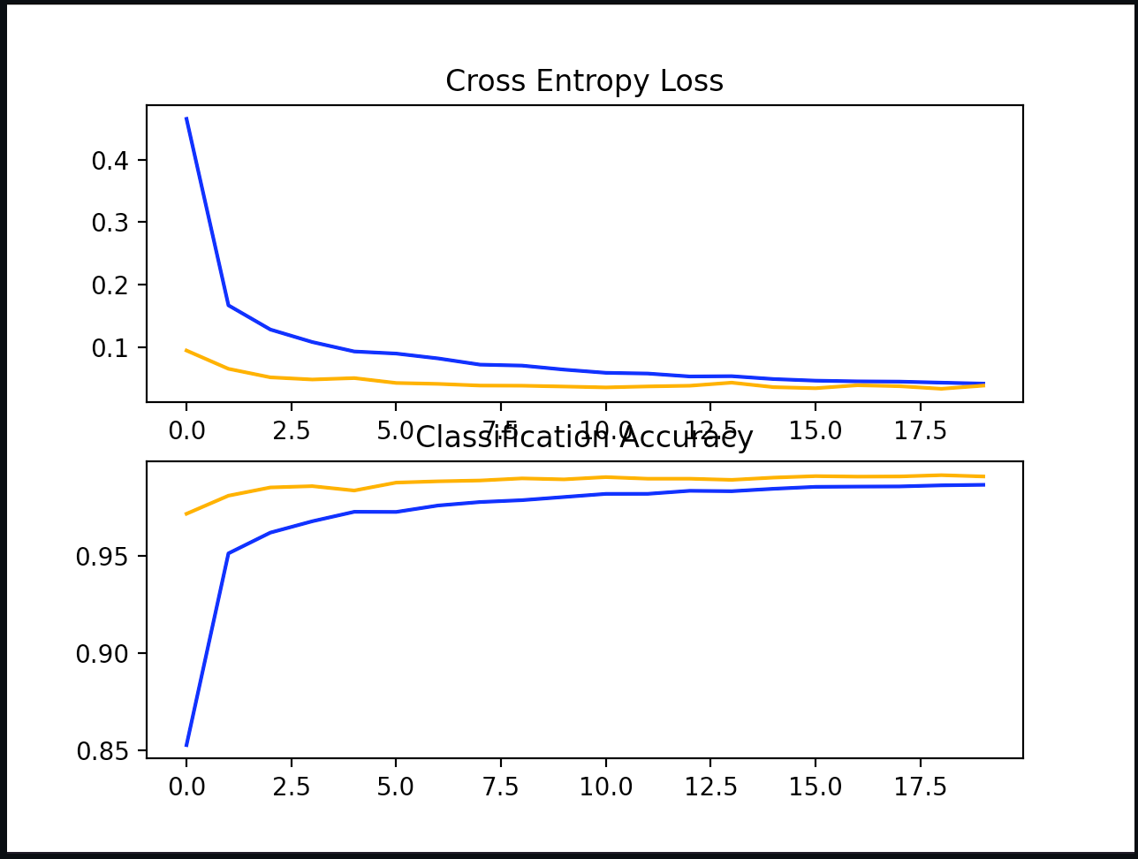

During the testing phase, our model was able to recognize pretty big and wide handwritten characters. We observed that loading and resizing of the images can invalidate the images leading to subsequent misrecognition of images.

Some examples of images that were recognized and those that were not recognized are shown below:

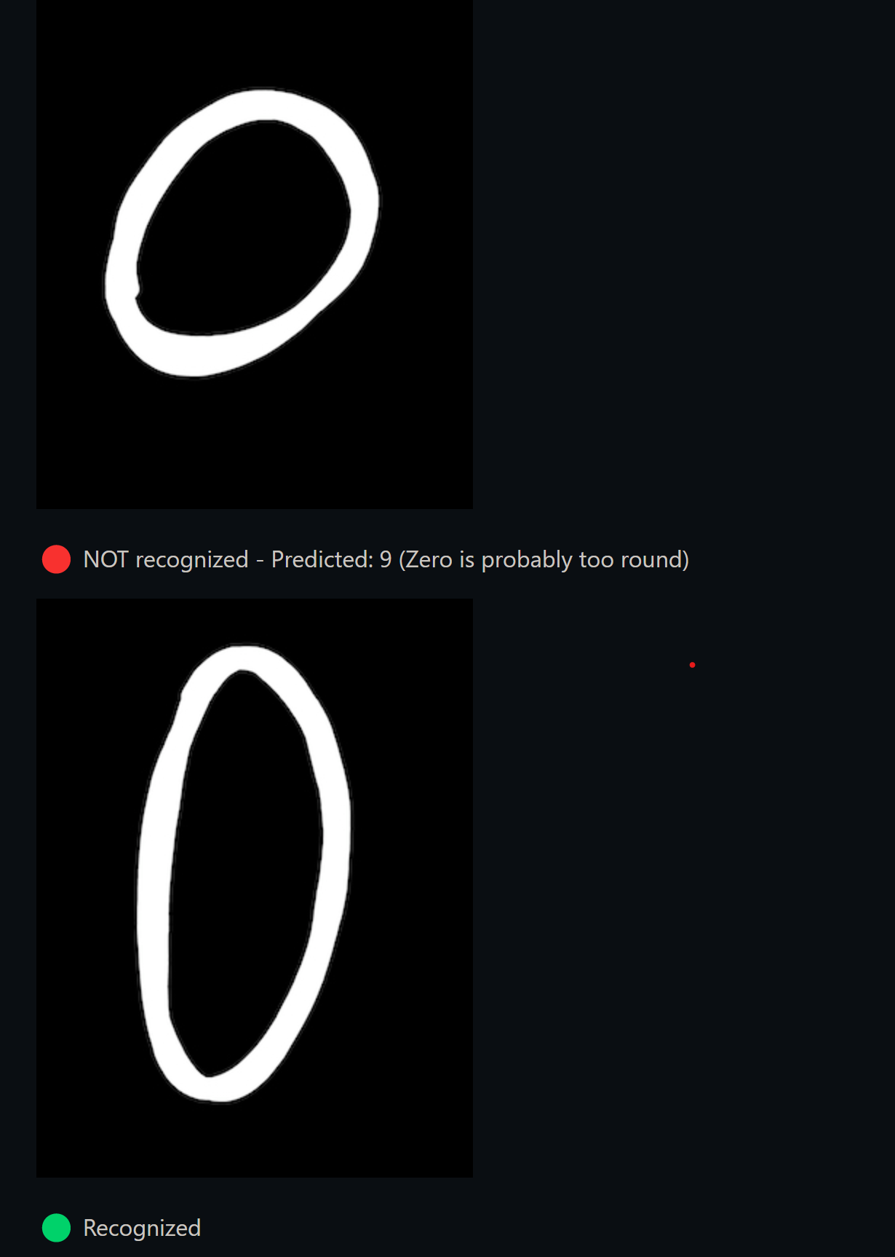

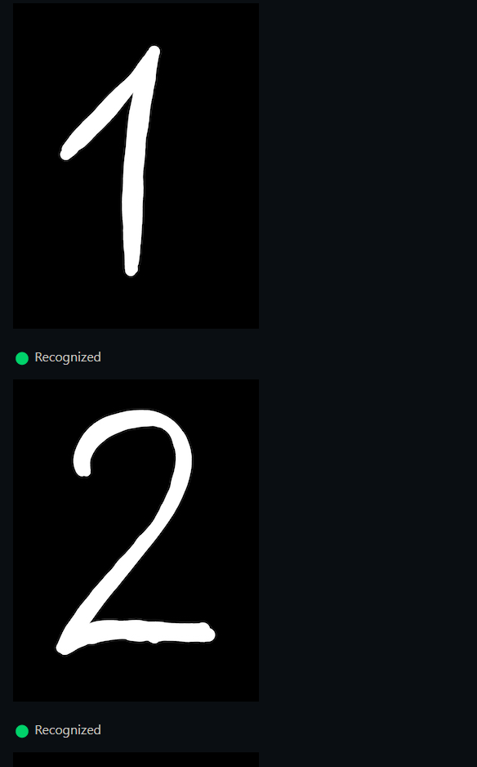

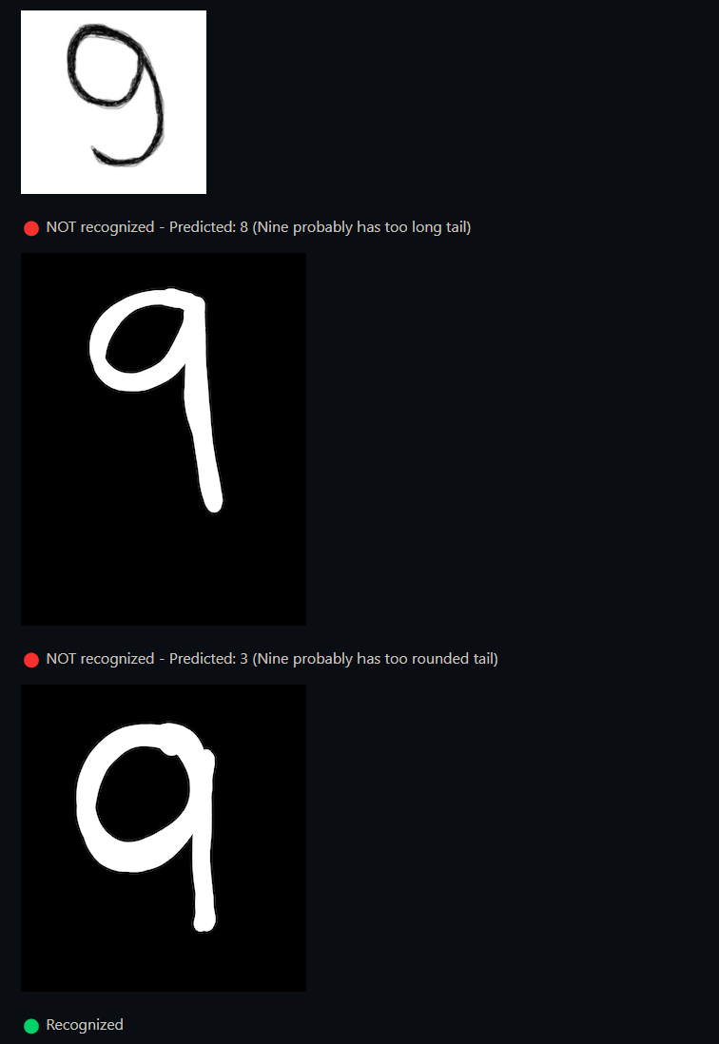

**REFERENCES:**

* **https://machinelearningmastery.com/how-to-develop-a-convolutional-neural-network-from-scratch-for-mnist-handwritten-digit-classification/**
* **stackoverflow**
* **tensorflow documentation**
* **https://blog.devgenius.io/handwritten-text-recognition-using-convolutional-neural-networks-cnn-714d69d28c9a**
* **https://www.researchgate.net/publication/334957576_A_Survey_of_Handwritten_Character_Recognition_with_MNIST_and_EMNIST**